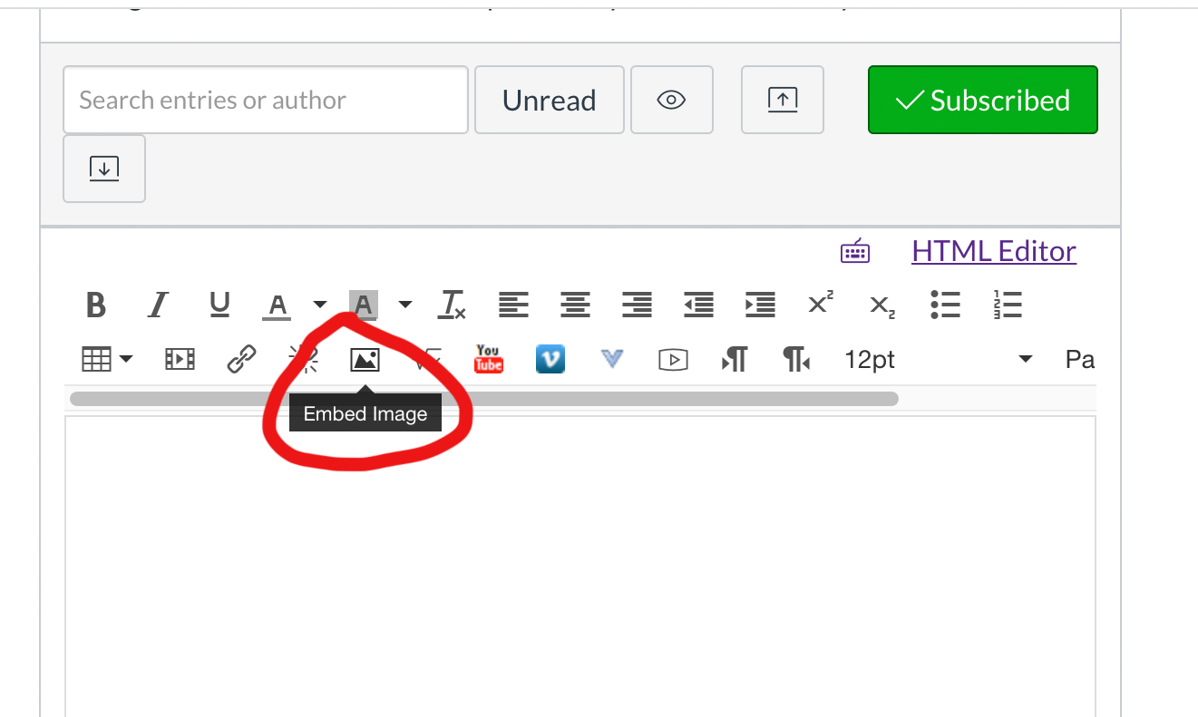

Click the picture icon to open the Insert/Edit window.
- To upload an image from your device: chose Canvas > "My Files" > then select "Upload button" > pick the file from your device/computer location> select open > select update > image is now embedded in your post as requested!
- You can add text/comment below or above your image if you desire.
- Click “Post Reply” when you’re finished adding content.
- Embedded images can be seen by everyone without the need to download attachments—this makes the viewing process much easier for all of us.

