SciENcv, ORCID ID and My NCBI

Mary Lisa Pories, PhD, CRA, Sponsored Programs Officer, East Carolina University

Kerry Sewell, MSLS, Research Development Director, College of Health and Human Performance, East Carolina University

“SciENcv is an application in My NCBI that helps you create and manage documents in support of grant applications with participating agencies. In SciENcv you can document your education, employment, research activities, publications, honors, research grants, and other professional contributions. My NCBI users can create multiple SciENcv profiles in official biographical sketch formats, for the [National Institutes of Health](https://www.nih.gov/) (NIH), the [National Science Foundation](http://www.nsf.gov/) (NSF), and the [Institute of Education Sciences](http://ies.ed.gov/) (IES), which can be used for grant submissions. In addition, the SciENcv application can be used to create the official NSF Current and Pending (Other) Support document.

NIH [eRA Commons](https://public.era.nih.gov/), [NSF](https://identity.research.gov/sso/UI/Login?module=nsf&env=prvw&app=portal), and ORCID account holders who have linked their accounts to NCBI can populate their SciENcv profiles with the information stored in their eRA, [NSF](https://identity.research.gov/sso/UI/Login?module=nsf&env=prvw&app=portal), or ORCID accounts. The information transferred to SciENcv can be changed, hidden, augmented, or deleted. SciENcv users control the content displayed in their SciENcv profiles.”

<https://www.ncbi.nlm.nih.gov/books/NBK154494/>

How to update your publications into My Bibliography

Log into NCBI:

<https://www.ncbi.nlm.nih.gov/>

using your eRA commons login is the easiest.

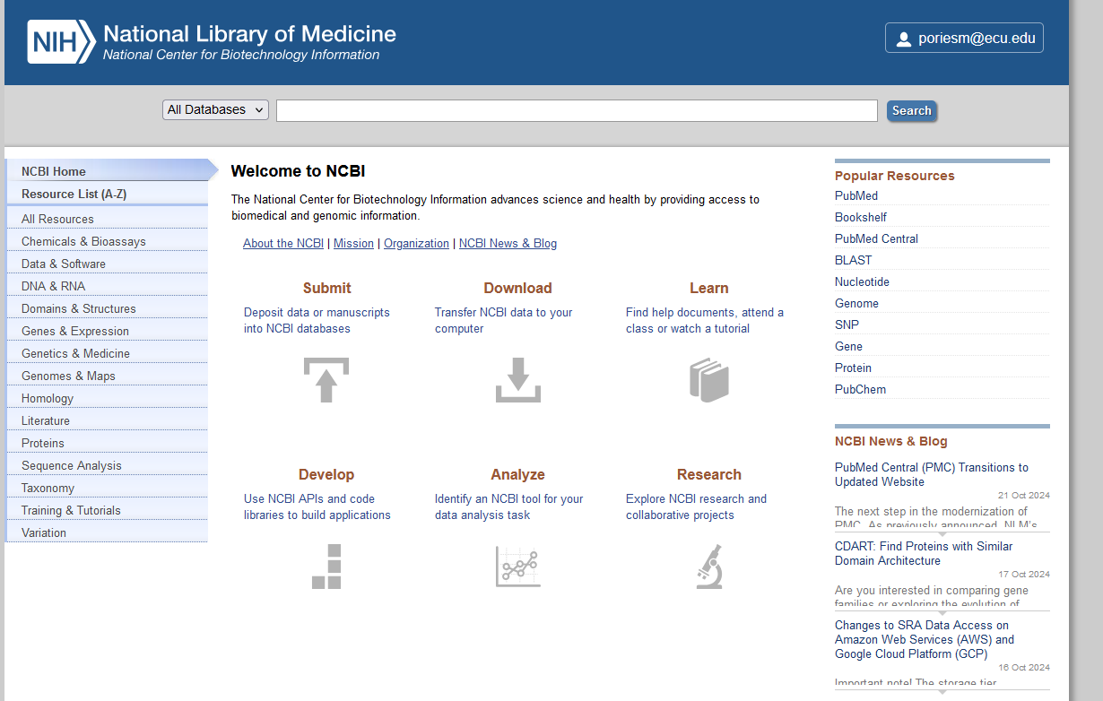

**Click on my dashboard by placing your mouse over your name at top (for me** [**poriesm@ecu.edu**](mailto:poriesm@ecu.edu)**)**

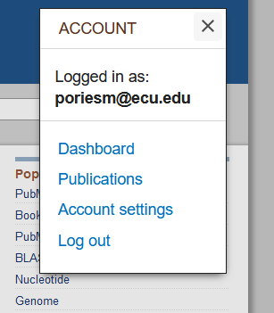

**Select Dashboard -** **once you see your dashboard, Select Manage my bibliography**  
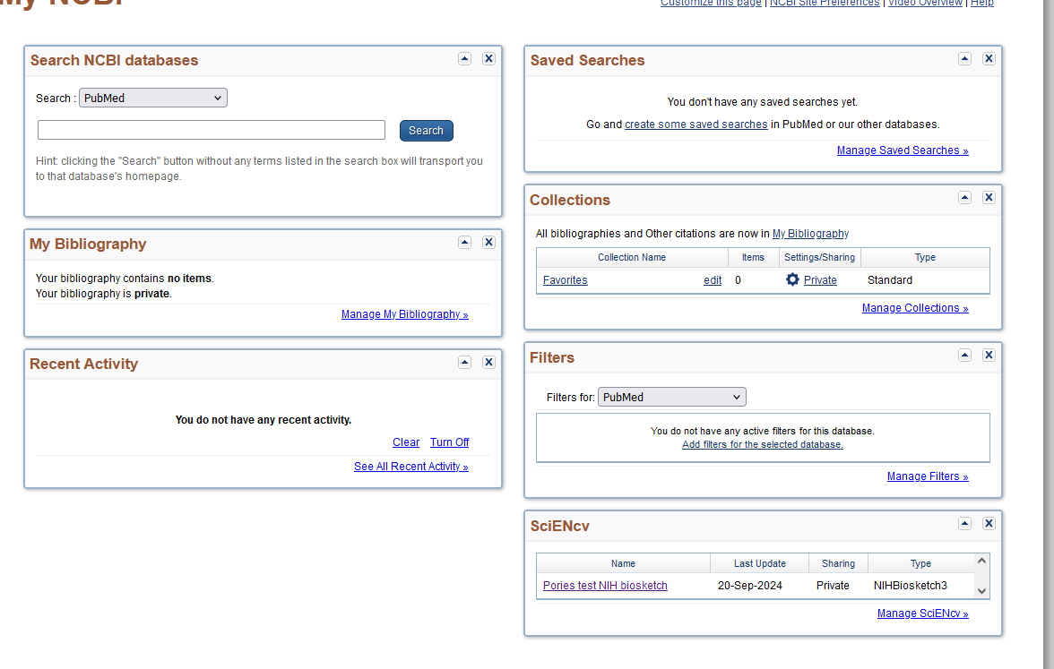

**The first time you use My Bibliography, you’ll see the following:**

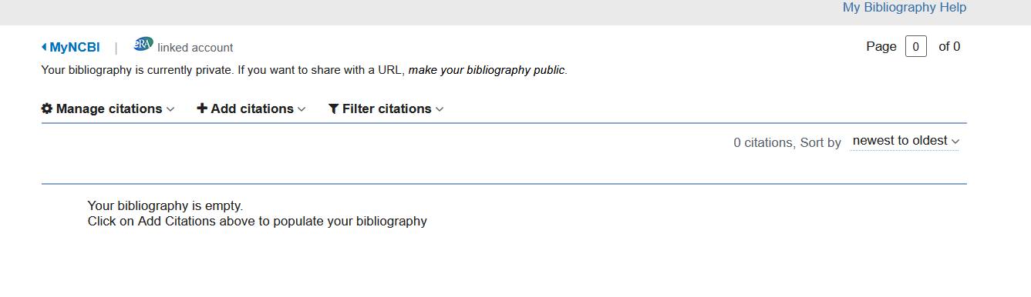

**To add citations, select Add citations**

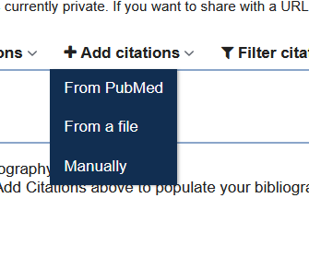

**There are two primary routes for adding citations**

**From Pubmed: *this works well if you have publications within journals indexed in PubMed or included in PubMed Central—it’s easiest to locate them one by one using a list of the DOIs or PMIDs for your publications. It can also work if you have a unique last name.***

From Pubmed:

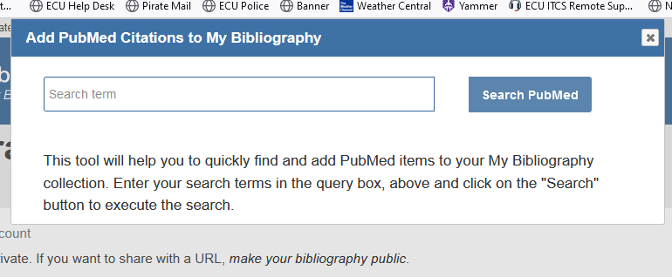

**The other route for adding citations is to do so Manually: *this is better if you have publications not included in PubMed***

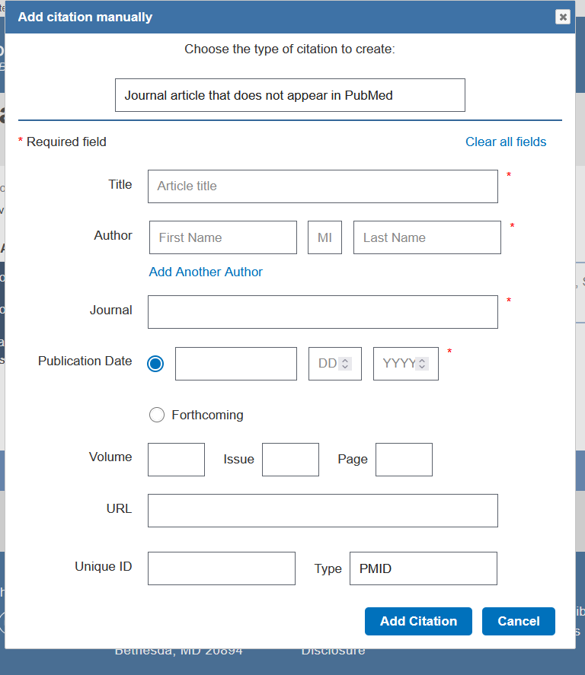

**Adding citations is part of the process. To share your bibliography, you’ll need to set the bibliography as public. You can still hide individual citations in your bibliography**

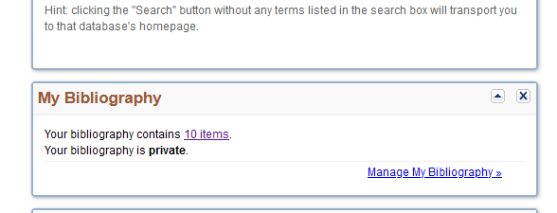

**You can also add delegates to your account and link your ORCID account. To link your ORCID account, go to your account settings and add ORCID as a linked account.**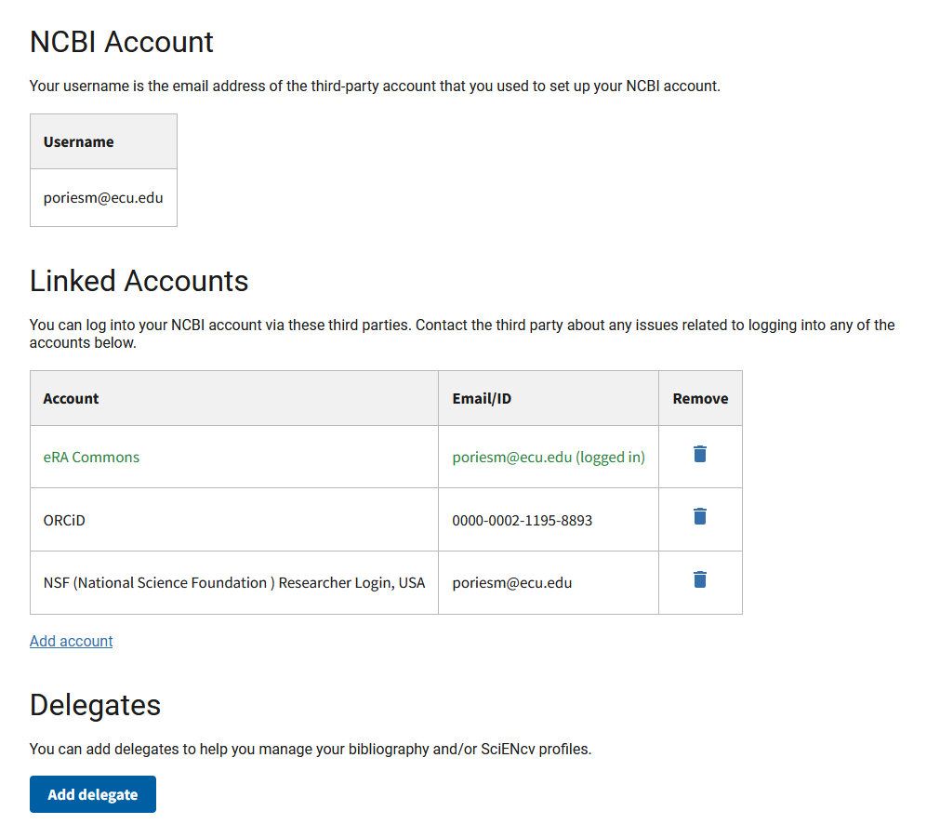

Once you have your ORCID account linked to your NCBI account, you may not want or need to manage a bibliography within NCBI since your Biosketch can pull your relevant/related citations from your ORCID account to help with adding citations to your biosketch, BUT keep in mind that your NIH Biosketch is allowed to have a hyperlink to your full set of publications in your **MyNCBI bibliography** and that’s the way to show reviewers the full extent of your research publications productivity. A link to your full list of publications through your ORCID is not currently allowed for biosketches.

<https://www.ncbi.nlm.nih.gov/books/NBK154494/>

Once you have your ORCID account linked to your NCBI account, you may not want or need to manage a bibliography within NCBI since your Biosketch can pull your relevant/related citations from your ORCID account to help with adding citations to your biosketch, BUT keep in mind that your Biosketch is allowed to have a hyperlink to your full set of publications in your **MyNCBI bibliography** and that’s the way to show reviewers the full extent of your research publications productivity. A link to your full list of publications through your ORCID is not currently allowed for biosketches.

Your MyBibliography is accessible through the Dashboard when you login to My NCBI

1. To add citations to your MyBibliography, there are two primary ways of getting citations in:
   1. Find citations within PubMed and add them.
   2. Bulk upload from a citation manager where you have all of your publications and presentations: For publications and presentations, you can bulk import those from a single file, such as an EndNote file or a Zotero file for all of your publications/presentations.
      1. Steps: On the MyBibliography page, Click Add Citations and choose ‘From a file’ and select the file you’ve exported from your Citation Manager to upload into PubMed. You should export the file of your publications in .RIS format to facilitate upload.
   3. Manually adding single publications and presentations: You can also add single citations manually within MyBibliography. This is useful if you just have a couple of items to add, such as conference presentations. Within MyBibliography, click on Add Citations and choose ‘Manually.’ You’ll choose the publication type and then provide all the necessary citation information for the item.
2. There may be some citations you don’t want to make visible for various reasons. If you need to do this, you can select the citation you want to hide, then click Manage Citations and choose ‘Set to Private.’

National Library of Medicine provides step-by-step instructions as well: <https://www.ncbi.nlm.nih.gov/books/NBK154494/#sciencv.Creating_SciENcv_Documents>